WCF TESTING TOOL GUIDELINES

Introduction: - It is software made in Microsoft .net WPF, WCF and C#. It takes input as a wcf service base address. As output, it lists all the methods of the service and on selection of any method it asks for the method's parameters (if any). Once we enter the parameters and click the run button, it shows the result of the methods on right panel.

Using Guidelines:-
Step 1:- Download the setup file from http://wcftestingtool.sourceforge.net or download the source code from https://wcftestingtool.svn.sourceforge.net/svnroot/wcftestingtool using svn. First of all install the application. It creates shortcut to your desktop named as WCFTestingTool, double click and run it. If you have downloaded the source code you can run directly by pressing ctrl+f5. Once you run you will see the screen given below:-
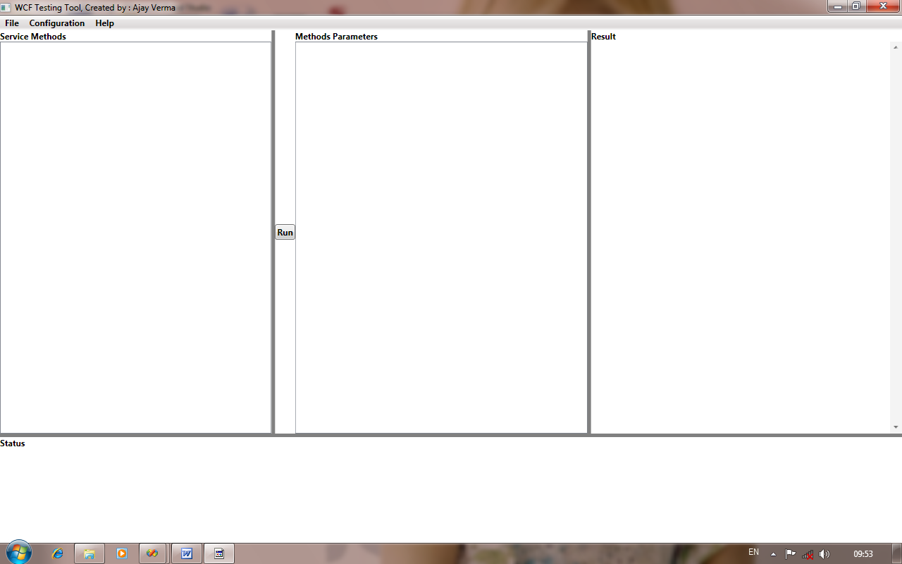

Step 2: Default path for SvcUtil.exe and csc.exe are C:\Program Files\Microsoft SDKs\Windows\v6.0A\bin\SvcUtil.exe and C:\WINDOWS\Microsoft.NET\Framework\v3.5\csc.exe respectively. Cross check the path in your pc. If you are having different location on your pc for SvcUtil.exe and csc.exe then you can set the path using configuration Menu. Click the configuration menu and sub items inside it and browse the correct path. : Configuration done.

Step 3: Now click the file menu and click open sub menu inside it. It will open new window to enter the end point address of the wcf service. Make sure that wcf service is running.
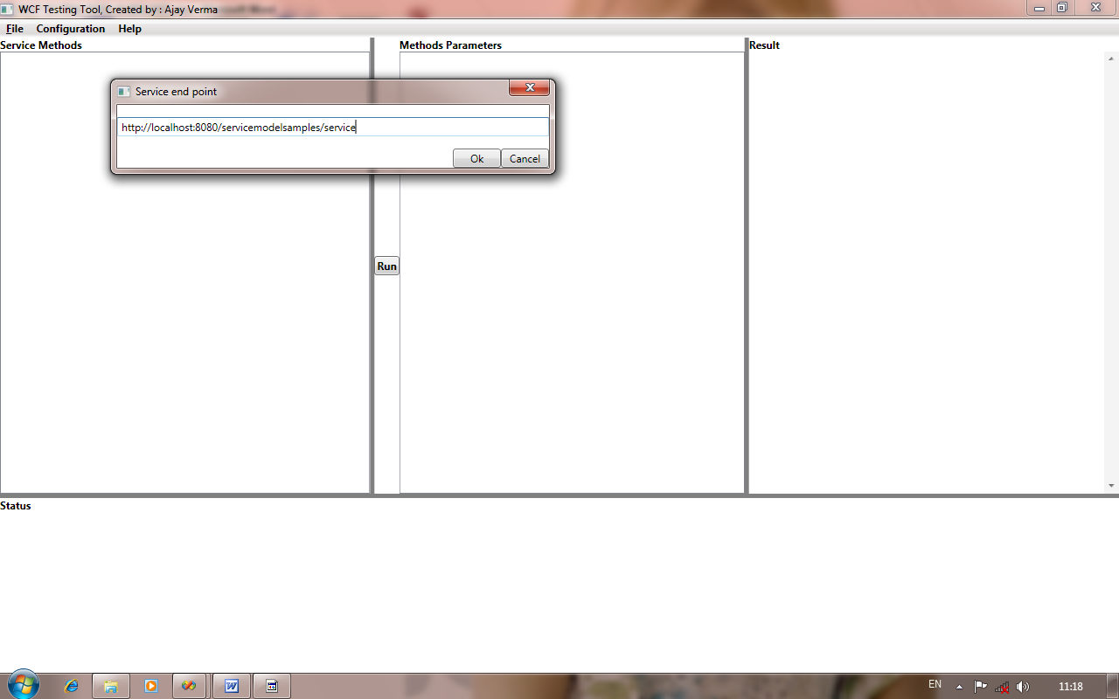

Click ok button. It will list all the methods of the service inside service methods area.
Like below:-
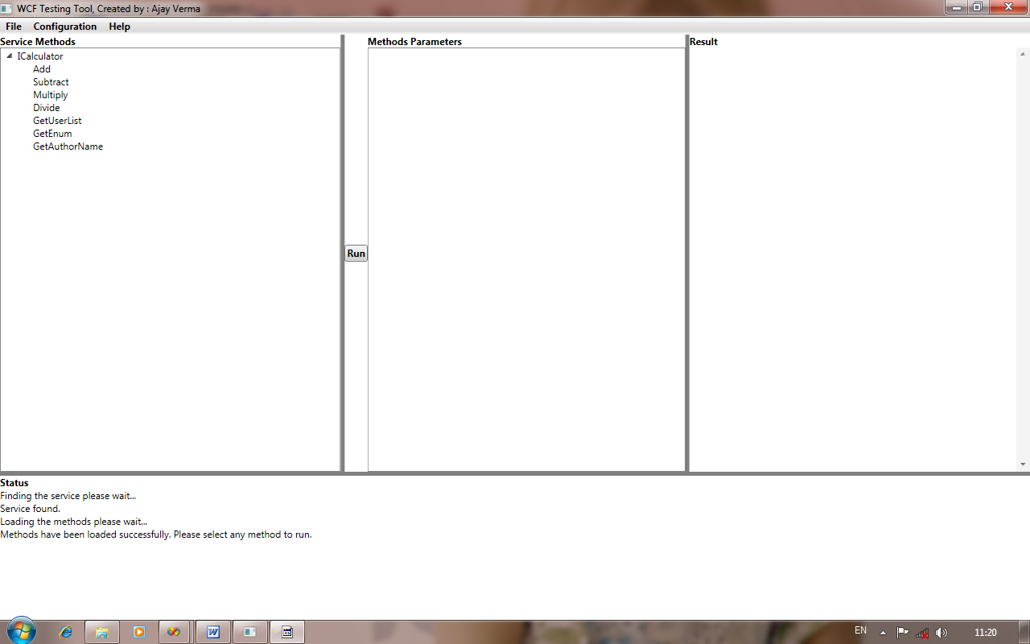

Step 4: Now select the method you want to run. It will list all the parameters of the method to method parameters area of the screen. It will look like below screen:-
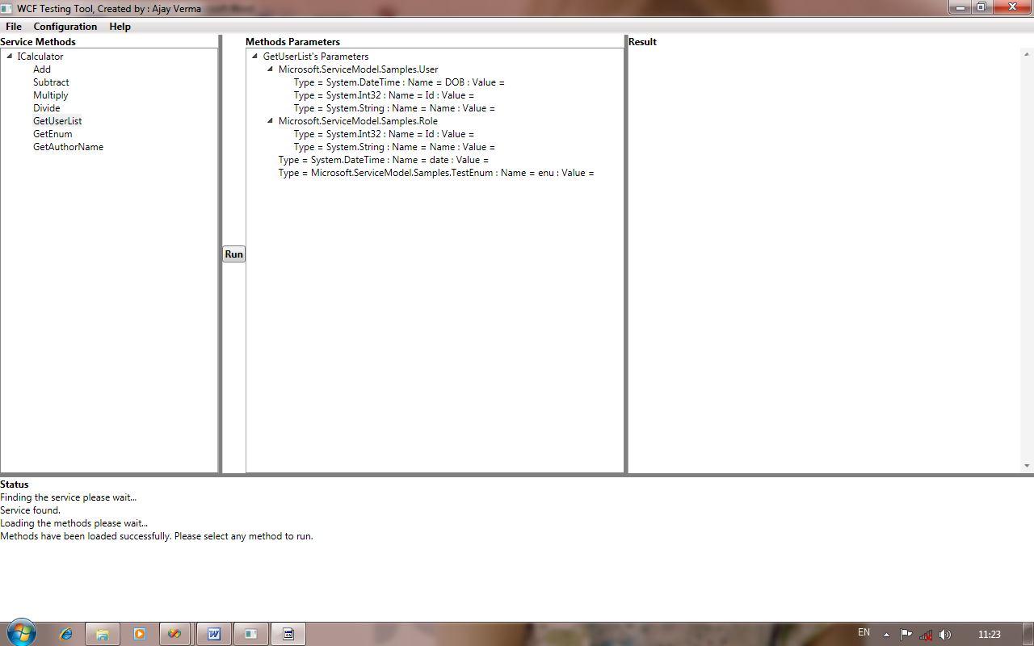

Step 5: When you click above the parameter name in the list. It will open new window and ask for the parameter. It will validate type automatically. For enum type, it will show you dropdown list select the value from it. For the other type it will show textbox enter your value to textbox. New open window looks like below:-
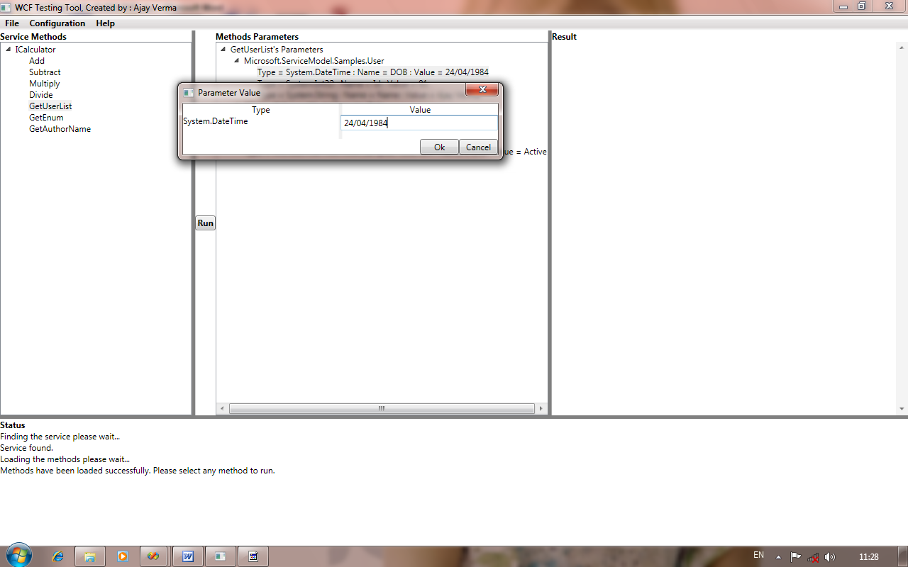

Step 6: Finally click the run button. It will show the result inside result area of the screen. Like below:-
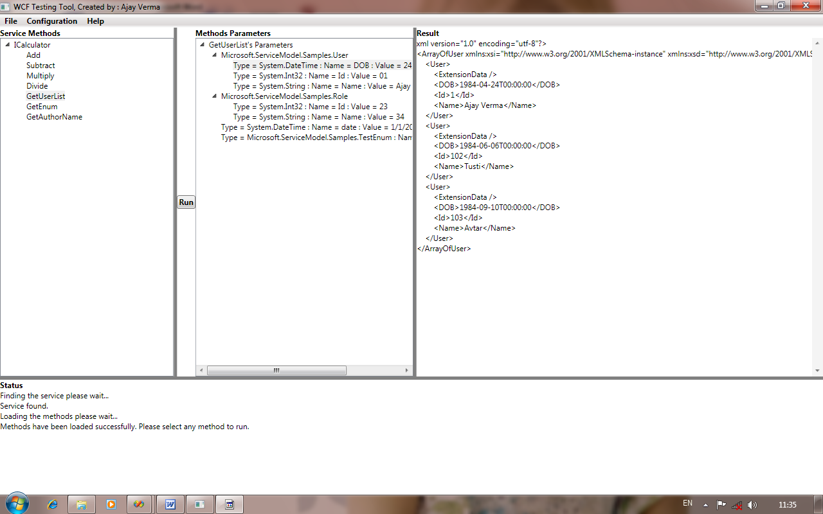

Note: Very important point. I usually forget at first time. Add the client configuration file i.e. web.config or app.config. By default application will use the app.config file which is generated by SvcUtil.exe. To add your client configuration to access the service, click the Configuration menu and click Add Client Config File submenu and give the correct path of your configuration file.

Thank you very much for giving your valuable time to test and use this application.

Thanks and regards,
Ajay Kumar Verma

